Alla G. Vronskaya
Massachusetts Institute of Technology
State Institute for Art Studies, Moscow

Lissitzky, El (1890-1941)
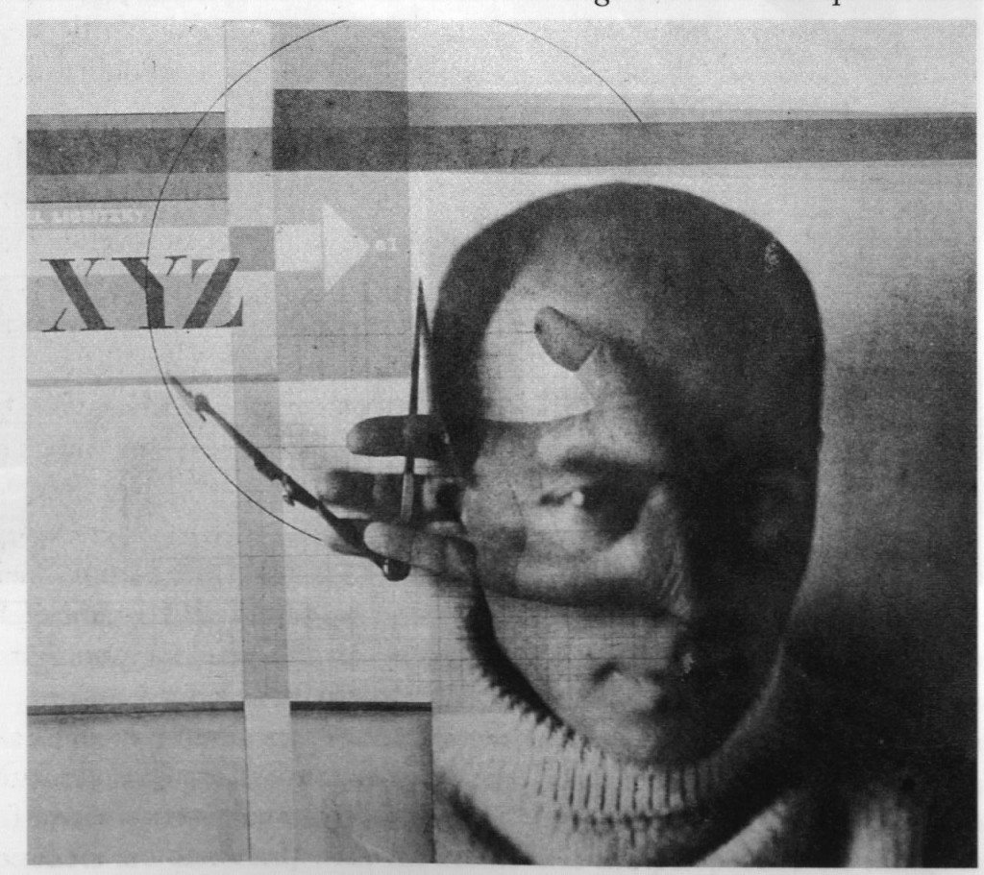
El Lissitzky, Self-Portrait (The Constructor), 1924
http://designpublic.in/blog/what-is-the-relationship-between-innovation-and-design/

The Soviet artist, photographer, designer, and architect Lazar’ Markovich (Mordukhaevich) Lissitzky grew up in a Jewish family in Smolensk, West of Russia. In 1909 Lissitzky moved to Germany, where he studied architectural engineering at Darmstadt Technische Hochschule. While living in Germany, Lissitzky travelled throughout Europe and became connected with the circle of Russian-Jewish painters in Paris. With the advent of the First World War, he was forced to return to Russia. There, Lissitzky enrolled into the Riga (today in Latvia) Polytechnic Institute, which was in evacuation in Moscow during the war, and continued pursuing his interest in Jewish culture. At that time, alongside such artists as MARC CHAGALL, Lissitzky was one of the major protagonists of the “Jewish Renaissance,” which took place in the former Russian Empire after the 1917 Soviet Revolution, which abolished the tsarist anti-Semitic laws and regulations. Lissitzky’s most famous works from this period are richly illustrated children books, such as Had gadya (One Goat), a traditional Passover song.

In 1919, after an invitation from Chagall, Lissitzky became the head of the architecture department at the Higher Artistic Workshops in Vitebsk (a small town in contemporary Belarus’ with a significant Jewish population, where Lissitzky also lived as a child). The school was soon joined by KAZIMIR MALEVICH, whose presence stimulated Lissitzky’s growing interest in SUPREMATISM. In 1920, Malevich led the artistic group UNOVIS (from Russian utverditeli novogo iskusstva, “those who affirm the new art”), which aimed at politicizing Suprematism and transforming it into a weapon of mass propaganda through posters, wall-painting, and colourful street decorations. Some of Lissitzky’s best-known work of the period - Suprematist propaganda posters such as Beat the Whites with the Red Wedge (1920) and The Machines of Depots and Factories are Waiting for You. Let’s Move Production! (1920) - was produced within the framework of the UNOVIS programme. The UNOVIS agenda also shaped Lissitzky’s own idiosyncratic art form that he conceived in Vitebsk and continued to develop during the following years – the Proun (from Russian proekt utverzhdenia novogo, “a project for the affirmation of the new”). Imagined as a laboratory rather than a mass art form, prouns aimed to bridge painting with architecture, supplementing the conventions of Suprematist geometric representation with three-dimensional geometric forms, axonometry (a method of architectural representation popular among modernist architects) and perspectival constructions.

In 1921, Lissitzky accepted the position of a cultural representative of Russia in Germany and left for Berlin, where he acted as the intermediary between left Russian and Western artists (organizing, for example, the First Soviet Art Exhibition in Berlin and Amsterdam in 1922-23). In 1922, together with the Russian-Jewish writer Ilya Ehrenburg, Lissitzky published the trilingual journal Veshch-Gegenstand-Objekt, which was devoted to all aspects of modernist artistic production across Europe. In Berlin, Lissitzky became associated with the leaders of European modernism: MOHOLY-NAGY, THEO VAN DOESBURG, and the DADAISTS, most notably, KURT SCHWITTERS (with whom he co-authored an essay “Nasci” for the Dadaist journal Merz). In 1923, during VLADIMIR MAYAKOVSKY’s stay in Berlin, Lissitzky designed the poet’s book For the Voice (Dlia golosa) in a more Constructivist than a Suprematist style. Next year, after a flare-up of tuberculosis, Lissizky moved to a sanatorium in Locarno (Switzerland), where he continued an association with Dadaism, co-authoring an illustrated brochure Die Kunstismen with Jean Arp in 1925. During the Swiss sojourn, Lissizky worked with advertisement designs, typography and photography, experimenting with various techniques of photographic manipulation and photomontage in such works as the 1924 self-portrait commonly known as The Constructor.

In 1925 Lissizky returned to Moscow, where during the first years after the return he was active as an architect and furniture designer, teaching at the Wood and Metal Department of VKhUTEIN (Higher Art and Technical Institute, formerly VKhUTEMAS). At this period, Lissitzky was an active member of the architectural group ASNOVA (Association of New Architects), led by architect NIKOLAI LADOVSKII. In opposition to the Constructivists, ASNOVA developed the RATIONALIST approach to architecture, which was based on the studies of spatial perception and emphasized formal expressivity as the goal of architectural work. Developing his interest in high-rise architecture that began already in Germany (Lissizky’s projects for Wolkenbügel, a “horizontal sky-scraper,” were devised in 1923-25), in 1926 Lissitzky together with Ladovskii co-edited the first (and the only) issue of Izvestia ASNOVA (ASNOVA Newsletter), devoted to sky-scraper construction. Lissizky’s only realized architectural project was the printing plant of journal Ogoniok in Moscow (1930-32).

In 1925, Lissitzky began work as an exhibition designer - an activity that would remain his predominant occupation throughout the rest of his life. He designed Raum für Konstruktive Kunst (Room for Constructive Art) at the Internationale Kunstausstellung in Dresden in 1925-26 and Abstraktes Kabinett in Hanover in 1927-28. In 1928, he worked on the Soviet sections of the Pressa exhibition in Cologne and the Film und Foto exhibition in Stuttgart, as well as the All-Union Polygraphic Exhibition in Moscow. Among Lissizky’s other major exhibition projects were Soviet pavilions at the Hygiene exhibition in Dresden and the International Fur Exhibition in Leipzig (both 1930), the Permanent Construction Exhibition in Moscow (1930s), the Soviet pavilion for the International Aviation Exhibition in Paris (1932), the International Exhibition in New York (1939), and the All-Soviet Agricultural Exhibition (1934-41). As the chief architect of the Park of Culture and Leisure in Moscow in 1929-33, Lissitzky introduced the solutions developed by him for exhibition design into the emerging practice of Soviet landscape architecture.

During the late 1920s-1930s, Lissitzky was also actively working with photomontage and book design. Accused of totalitarianism by later Western scholars, his photomontage work of the period included a large (24 x 3.5 meters) photomontage for the Soviet pavilion at the Pressa exhibition. Lissitzky’s major employment as a book designer was his continuous work (1932-41) on the general layout and cover design of international propaganda journal SSSR na stroike (USSR in Construction), where he was responsible for the design of the most ideologically important issues: those devoted to the Stalinist Constitution, the Red Army, the Navy, and the Dnepr Hydroelectric Station. Among the other journals designed by Lissitzky were Arkhitektura SSSR (Architecture of the USSR), Industria sotsializma (Socialist Industry), Sovetskaia Gruzia (Soviet Georgia), Sovetskie Subtropiki (Soviet Subtropics).

List of works

1920 Beat the Whites with the Red Wedge.

1920 The Machines of Depots and Factories are Waiting for You. Let’s Move Production!

1923 For the Voice (Dlia golosa).

1924 The Constructor, self-portrait.

1925 Die Kunstismen (with Jean Arp).

1930-32 Ogoniok Building, Moscow.

1925-26 Raum für Konstruktive Kunst (Room for Constructive Art) at the Internationale Kunstausstellung, Dresden, Germany.

1927-28 Abstraktes Kabinett, Hanover, Germany.

1928 Soviet section of the Pressa exhibition, Cologne, Germany.

1928 Film und Foto exhibition, Stuttgart, Germany.

1928 All-Union Polygraphic Exhibition, Moscow.

1932-41 SSSR na stroike (USSR in Construction).

References and further reading

Lissitzky-Kuppers, S. (1968) El Lissitzky: Life, Letters, Texts. London: Thames and Hudson.

Buchloh, B. (1984) “From Faktura to Factography,” October, October, # 30, Fall, 82-119.

Margolin, V. (1997) The Struggle for Utopia: Rodchenko, Lissitzky, Moholy-Nagy: 1917–1946. University of Chicago Press.

Tupitsyn, M. (1999) El Lissitzky: Beyond the Abstract Cabinet. Yale University Press,.

Perloff, N. and Reed, B., eds. (2003) Situating El Lissitzky: Vitebsk, Berlin, Moscow. Los Angeles: Getty Research Institute.

Visual Material

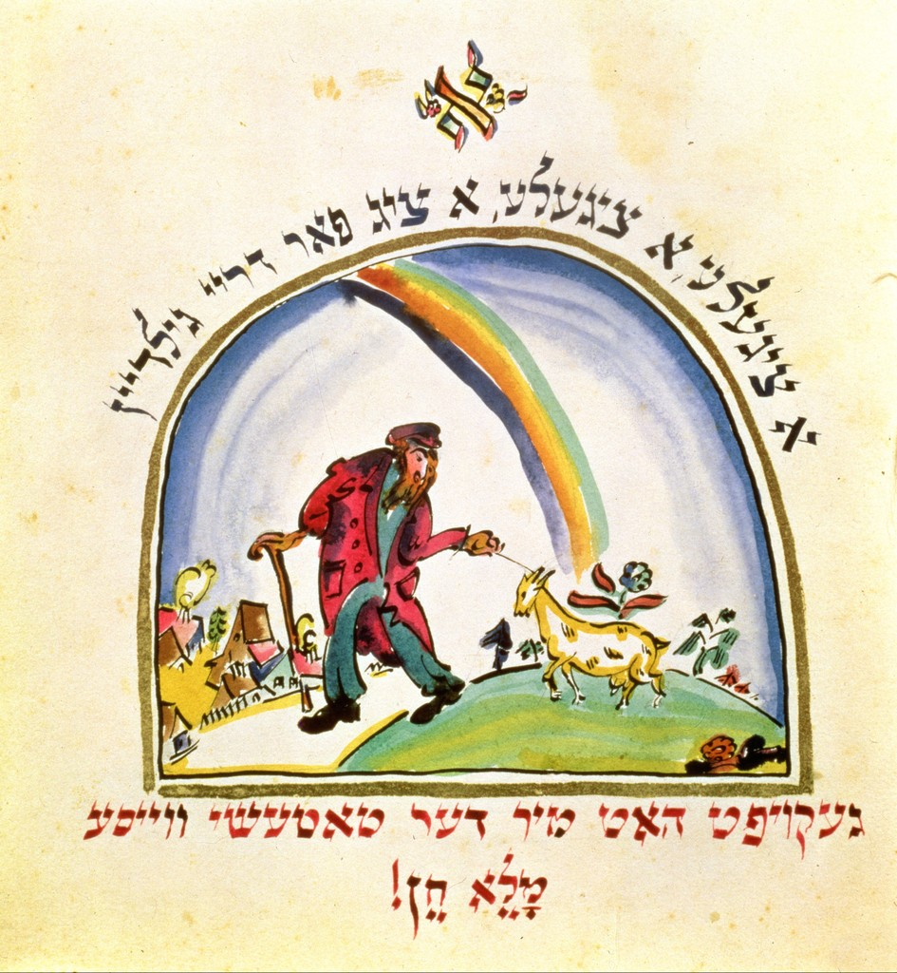
Illustration of “Chad Gadya” from the Haggadah, 1917
https://www.artfinder.com/work/illustration-for-chad-gadya-from-the-haggadah-el-lissitzky/

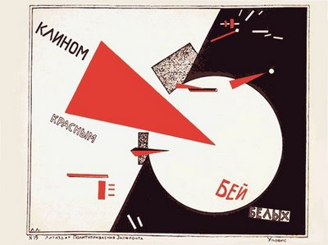
Beat the Whites with the Red Wedge, Poster, 1920
http://plakat-ussr.blogspot.com/2008/07/blog-post_12.html

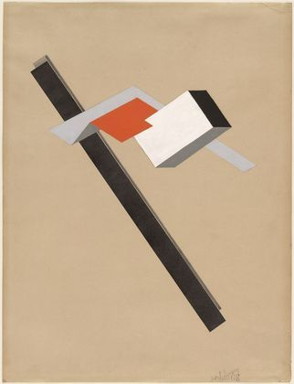
Proun, 1922-1923
Copyright: Museum of Modern Art, New York, http://www.moma.org/collection/browse_results.php?criteria=O%3AAD%3AE%3A3569&page_number=38&template_id=1&sort_order=1

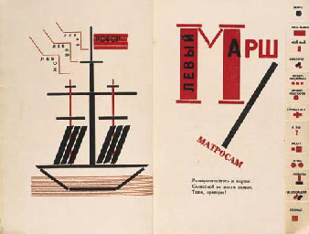
Vladimir Mayakovsky, Dlia golosa, Moscow: Gosudarstvennoe izd-vo, 1923 (book design by El Lissitzky)
http://www.christies.com/lotfinder/lot/maiakovsky-vladimir-et-el-lissitzky-1918730-details.aspx?pos=2&intObjectID=1918730&sid=&page=9

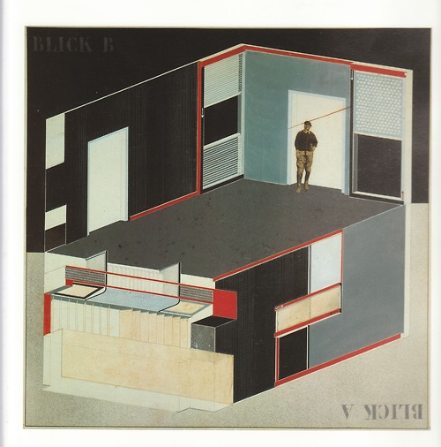
Project of Abstract Cabinet, Hannover, 1927
http://www.tumblr.com/tagged/el%20lissitzky

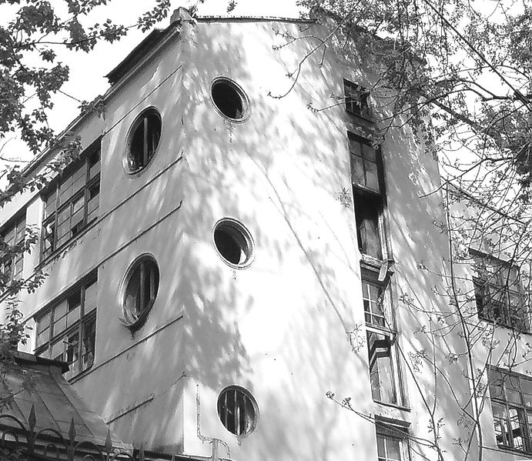
Ogonek Printing Plant, Moscow, 1930-1933
http://en.wikipedia.org/wiki/File:EL-LISITZKY-OGONYOK-1.jpg

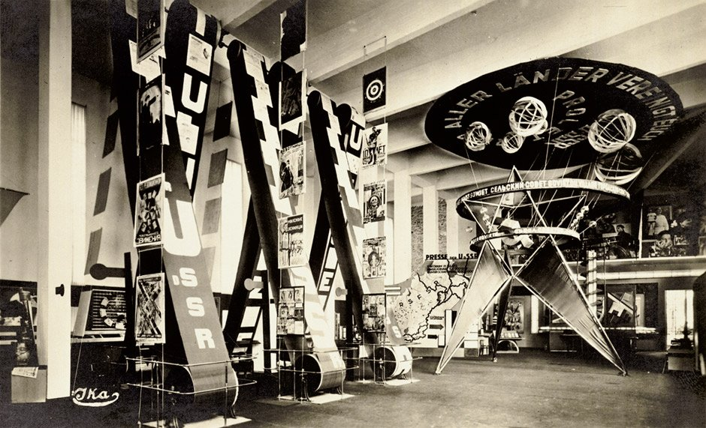
Soviet Pavilion at the Pressa Exhibition, Cologne, 1928.
http://www.liveauctioneers.com/item/11573985_lissitzky-el-pavilion-of-the-soviet-union-at-pr

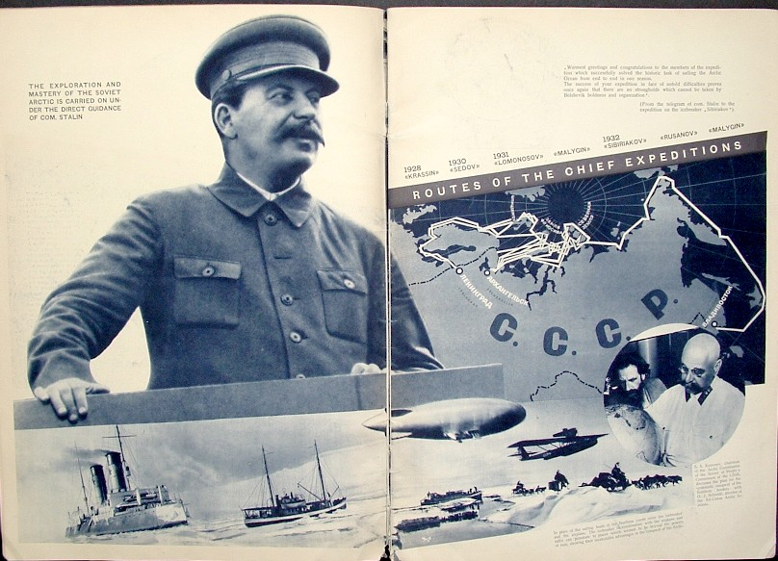
USSR in Construction, 1933, #9. Design by El Lissitzky.
http://www.russianartandbooks.com/cgi-bin/russianart/02853R

